The Election of Thomas Jefferson

- Federalists
- Anti-Federalists
- Election of 1800
- Electoral College
- Democratic-Republicans
- Aaron Burr
- Alexander Hamilton

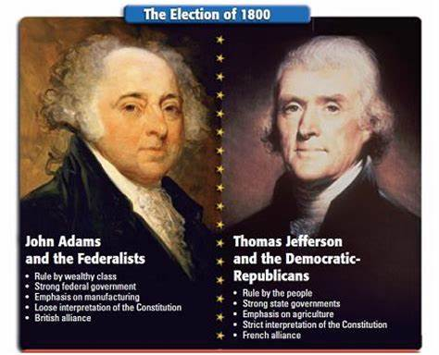
Louisiana Purchase

- Louisiana Purchase
- Lewis and Clark Expedition
- Meriwether Lewis
- William Clark

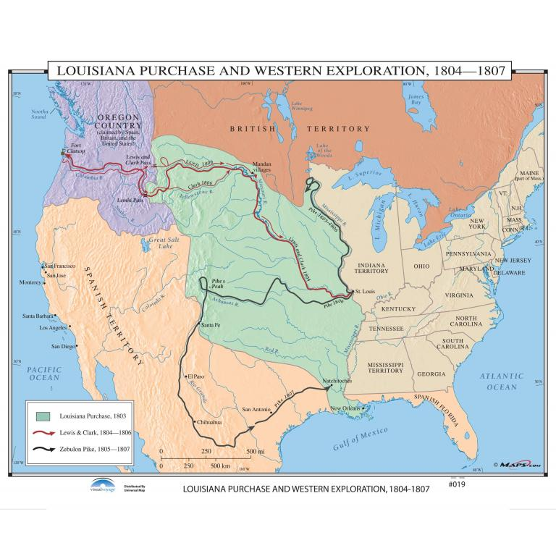
Marshall Court

- Judiciary Act of 1801
- “midnight judges”
- James Madison
- William Marbury
- Judiciary Act of 1789
- judicial review
- Marbury v. Madison (1803)
- John Marshall

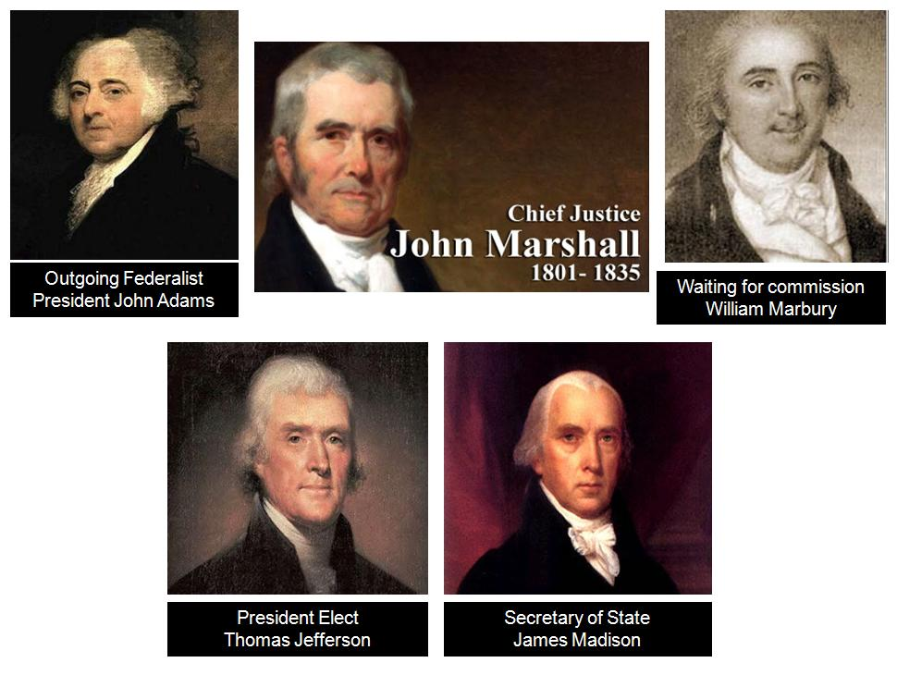
Jefferson’s Challenges

- Essex Junto
- John Randolph
- Tertium Quids
- Tripolitan War (Barbary States), 1801—1805
- Napoleonic War
- Chesapeake Affair
- Embargo Act of 1807
- Non-Intercourse Act of 1809

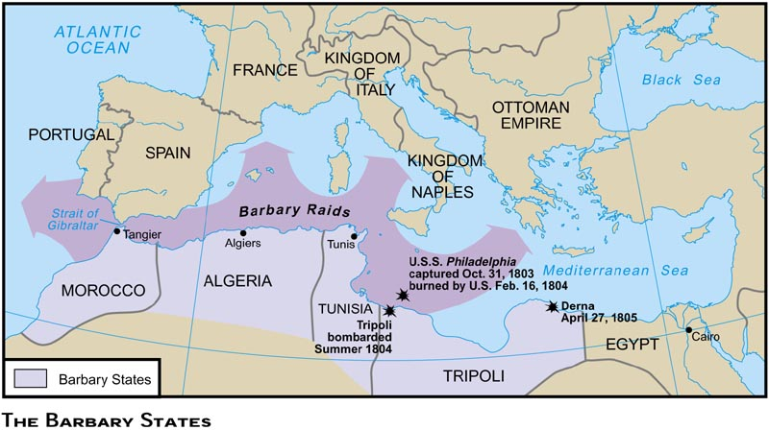
War of 1812

- James Madison [President, 1809—1817]
- “War Hawks”
- Henry Clay
- John C. Calhoun
- status quo ante-bellum
- William Henry Harrison
- Tecumseh
- Battle of Tippecanoe
- War of 1812
- Battle of Fort McHenry
- Francis Scott Key
- “The Star-Spangled Banner”
- Andrew Jackson
- Battle of New Orleans
- Treaty of Ghent

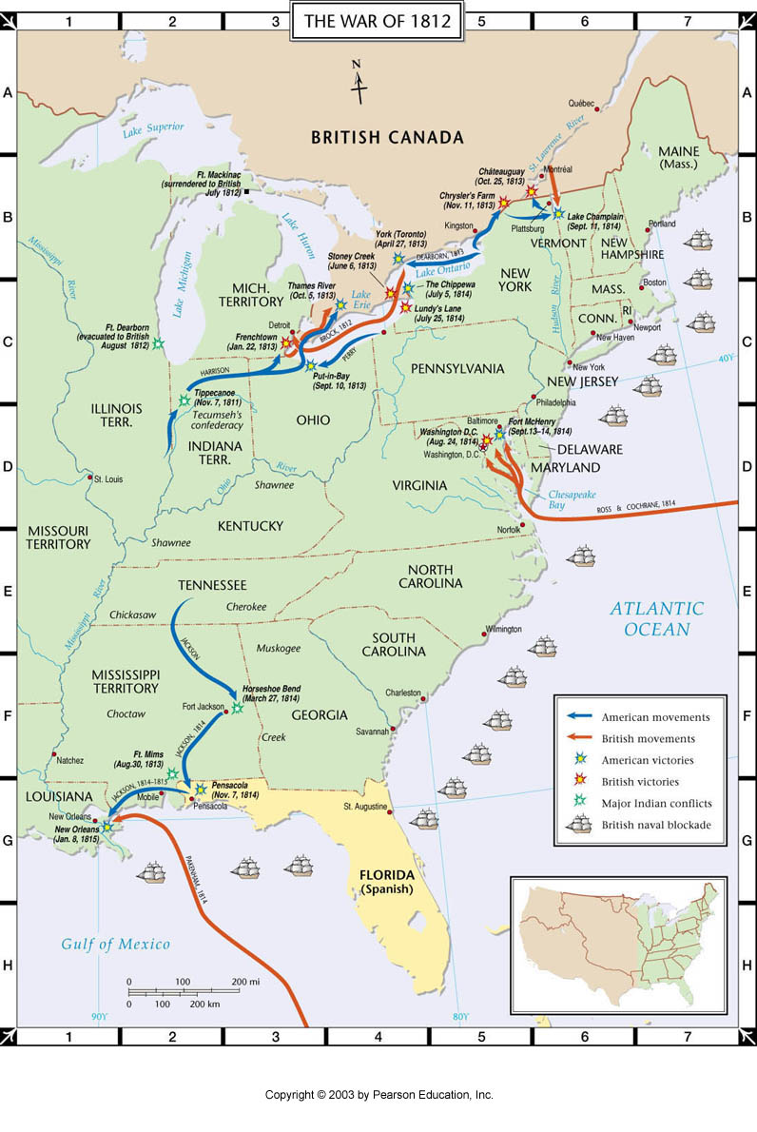
Ideological Divides in the United States

- Hartford Convention, 1814—1815
- Missouri Compromise of 1820
- James Tallmadge
- emancipation
- Henry Clay

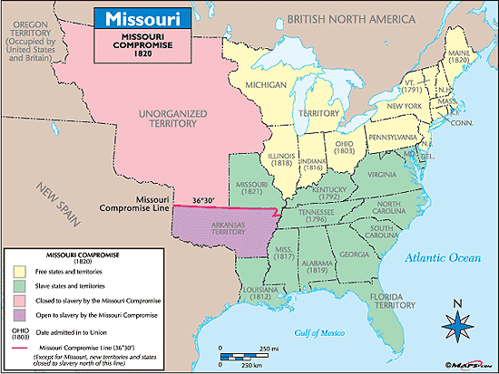

James Monroe and Era of Good Feelings

- James Monroe [President, 1817—1825]
- nationalism
- “Era of Good Feelings”
- John Quincy Adams
- Monroe Doctrine
- Henry Clay
- “American System”
- Tariff of 1816
- Second Bank of the United States (2BUS)
- internal improvements
- Daniel Webster
- John C. Calhoun
- Panic of 1819

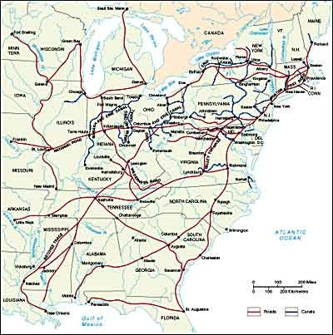
The Rise of the Two-Party System

- Presidential Election of 1824
- Democratic-Republicans
- Andrew Jackson
- Henry Clay
- John Quincy Adams [President, 1825—1829]
- “Corrupt Bargain”
- National Republicans
- Presidential Election of 1828
- Andrew Jackson [President, 1829—1837]
- Democrat Party
- Whig Party

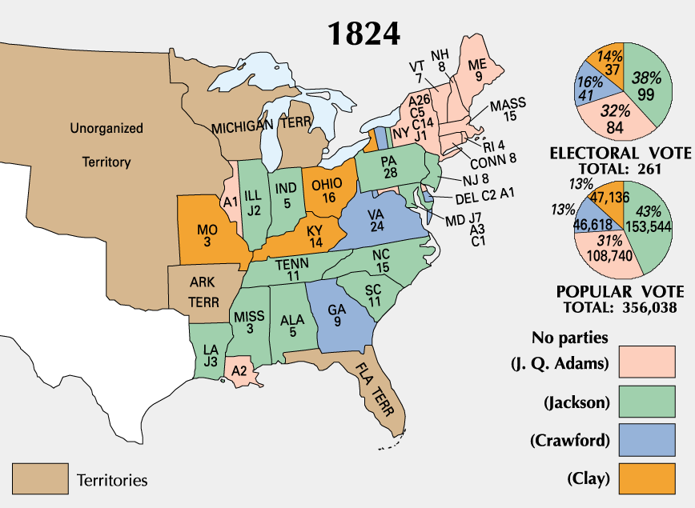

Challenges to Federal Authority

- McCulloch v. Maryland (1819)
- Jackson’s “War on the Second Bank of the United States”
- Nicholas Biddle
- Henry Clay
- Tariff of 1828
- Presidential Election of 1832
- “Pet Banks”
- Specie Circular
- Panic of 1837
- Nullification Crisis
- Henry Clay
- Tariff of 1832
- Force Bill
- Indian Removal Act of 1830
- Cherokee v. Georgia (1831)
- Worcester v. Georgia (1832)
- “Trail of Tears”

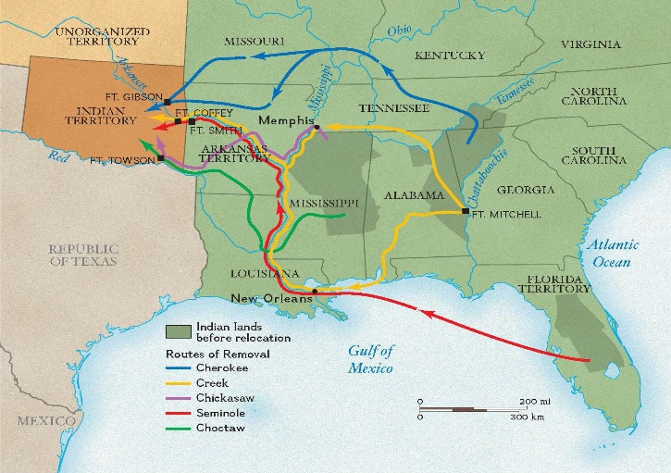
Religious Revival and Reform Movements

- Second Great Awakening
- Charles G. Finney
- revivals and conversions (faith, hard work, education, temperance)
- American Temperance Society
- temperance
- prohibition
- Dorothea Dix
- “Cult of Domesticity”
- Lucretia Mott
- Elizabeth Cady Stanton
- Susan B. Anthony
- Seneca Falls Convention
- “Declaration of Sentiments”
- abolition
- William Lloyd Garrison
- The Liberator
- American Antislavery Society
- Liberty Party
- Harriet Tubman
- “Underground Railroad”
- Sojourner Truth
- Frederick Douglass
- The North Star
- Denmark Vessey
- Nat Turner’s Rebellion
- Utopian Societies
- Mormonism
- Joseph Smith
- Brigham Young
- Romantic Era (Emotionalism, Man, and Nature)
- Transcendentalism
- Ralph Waldo Emerson
- Henry David Thoreau
- Walden
- “On Civil Disobedience”

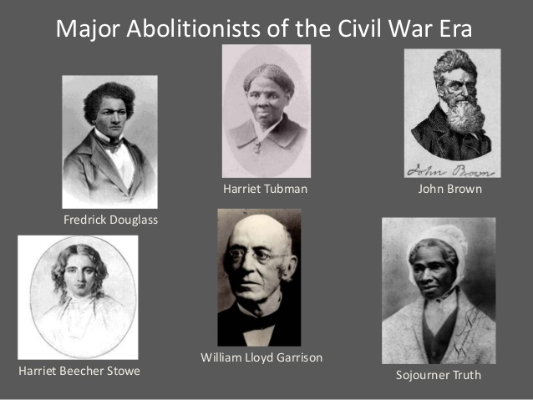
Birth of American Culture

- Hudson River School
- Romantic Era Art
- Knickerbockers (New York writers)
- Washington Irving
- James Fenimore Cooper

- Nathaniel Hawthorn
- Herman Melville

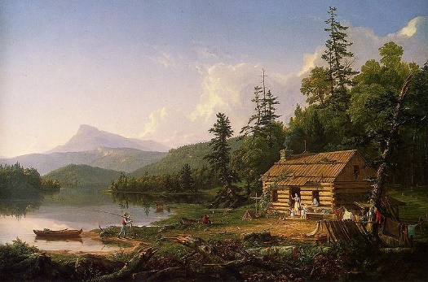

Economic and Social Revolution

- Regional Blocs (East, South, and West)
- Communication Revolution (telegraph)
- Transportation Revolution (canals, railroads, National Road)
- Immigration (Germans, Irish)
- Nativists
- American “Know Nothing” Party
- Market Revolution
- Industrial North (manufacturing)
- Agrarian Northwest (wheat, corn)
- Agrarian South (cotton, tobacco)
- Plantation Agriculture
- “King Cotton”
- Industrialization
- Eli Whitney
- “cotton gin”
- slavery
- slave codes
- frontier

