Manifest Destiny
- Manifest Destiny
- Convention of 1818
- Adams-Onis Treaty (Transcontinental Treaty), 1819
- Webster-Ashburton Treaty, 1842
- railroad and telegraph expansion
- Panic of 1837
- Great American Desert
- Far West
- Overland Trails: (Oregon, Santa Fe)
- mountain men
- Stephen Austin
- Antonio López de Santa Anna
- Sam Houston
- Texas Revolution, 1835—1836
- Alamo
- Battle of San Jacinto
- Wilmot Proviso

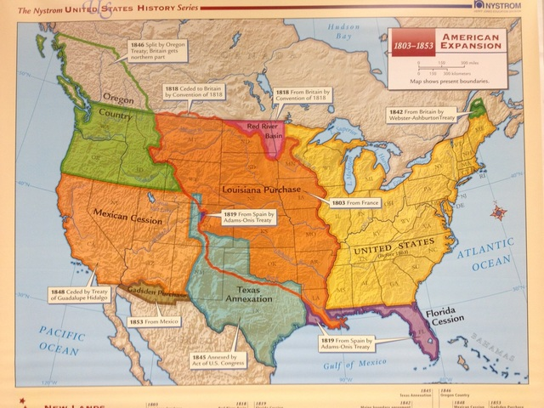

The Mexican-American War
- William Henry Harrison [President, 1841]
- John Tyler [President,
1841—1845]
- Texas Annexation
- Presidential Election of 1844
- “Fifty-four Forty, or Fight”
- James K. Polk [President,
1845—1849]
- Oregon Treaty, 1846
- Mexican War, 1846—1848
- Zachary Taylor
- Winfield Scott
- John C. Frémont
- “Bear Flag Revolt”
- Treaty of Guadalupe Hidalgo, 1848
- Mexican Cession

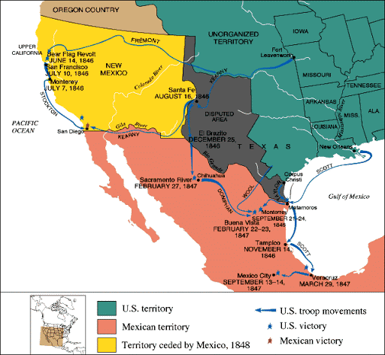
The Compromise of 1850
- Presidential Election of 1848
- Zachary Taylor, [President,
1849—1850]
- Stephen Douglas
- popular sovereignty
- “Great Debate”
- Henry Clay
- John C. Calhoun
- Daniel Webster
- Compromise of 1850
- Fugitive Slave Act of 1850
- Millard Fillmore, [President,
1850—1853]

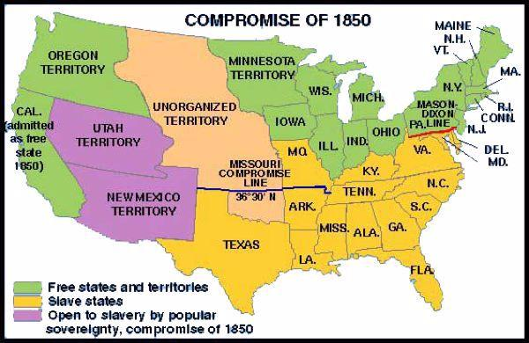

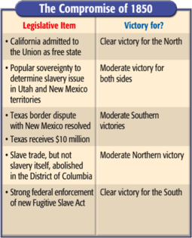
Sectional Conflict: Regional Differences

- Northern Industry v. Southern Agriculture
- Free Soil Party
- Abolitionist Movement
- Uncle Tom’s Cabin, 1852
- Harriett Beecher Stowe
- George Fitzhugh
- Conscience Whigs
- Presidential Election of 1852 (Issues)
- Franklin Pierce [President,
1853—1857]
- Harriett Tubman
- Underground Railroad

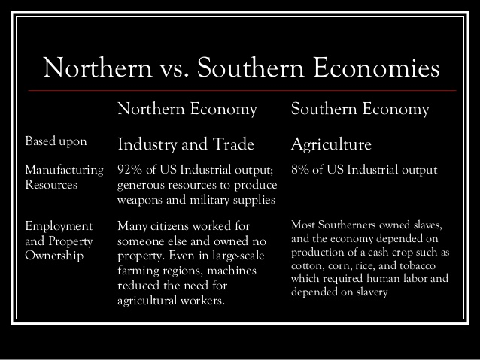

Failure of Compromise
- Kansas-Nebraska Act of 1854
- Republican Party
- “Bleeding Kansas”
- John Brown
- Pottawatomie Massacre
- “Crime Against Kansas Speech”
- Charles Sumner
- Preston Brooks
- Presidential Election of 1856 (Issues)
- John C. Frémont
- James Buchanan,
[President,
1857—1861]

- Roger Taney
- Dred Scott v. Sandford, 1857
- Lincoln-Douglas Debates
- “House Divided” Speech
- Harper’s Ferry Raid

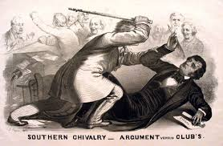
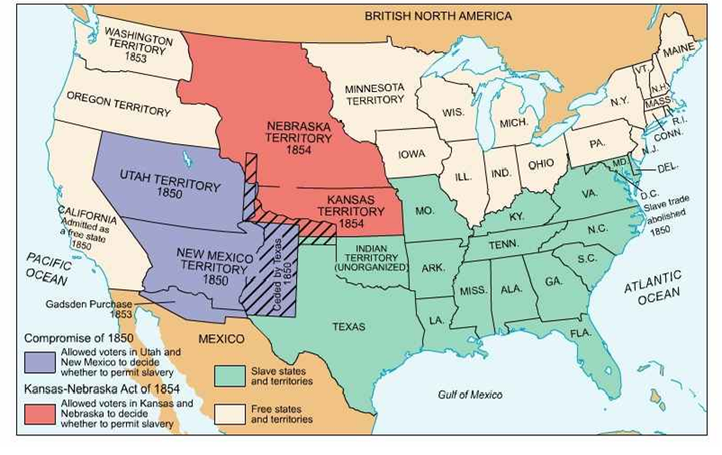
Election of 1860 and Secession
- Presidential Election of 1860 (issues)
- John Bell (Union-South)
- John C. Breckenridge (Democrat-South),
- Stephen Douglas (Democrat-North)
- Abraham Lincoln (Republican)
- secession
- Confederate States of America (CSA)
- Jefferson Davis
- Abraham Lincoln [President, 1861—1865]
- First Inaugural Address

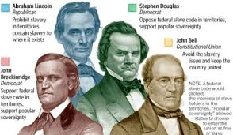

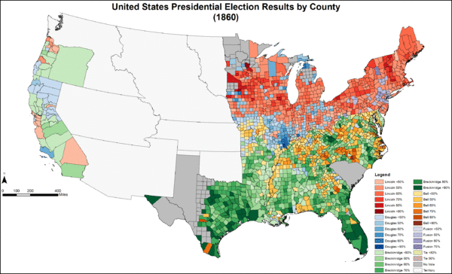

Military Conflict in the Civil War
- Border States (DE, MD, MO, KY)
- Fort Sumter
- First Battle of Bull Run, 1861
- Thomas “Stonewall” Jackson
- Winfield Scott
- Anaconda Plan
- George B. McClellan
- Robert E. Lee
- Battle of Shiloh, 1862
- Battle of Antietam, 1862
- Battle of Fredericksburg, 1862
- Battle of Chancellorsville, 1863
- Monitor v. Merrimac
- Ulysses S. Grant
- Battle of Gettysburg, 1863
- Siege of Vicksburg, 1863
- Siege of Atlanta, 1864
- Sherman’s “March to the Sea”
- Appomattox Court House
- Women in nursing
- 54th Massachusetts Infantry

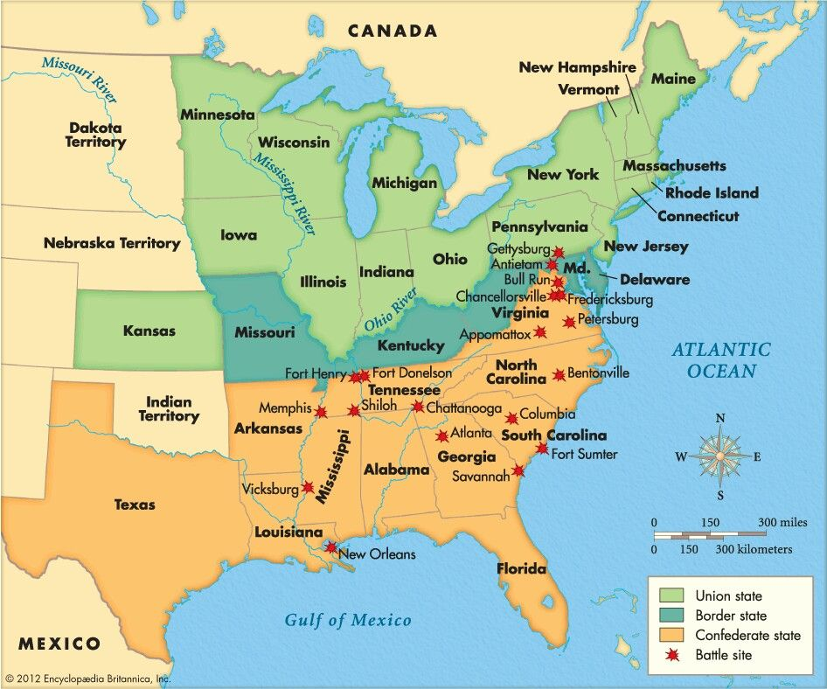
Government Policies in the Civil War

- Republicans and “Big Business”
- expanded executive power
- suspension of habeas corpus
- Morrill Tariff, 1861
- Morrill Land Grant, 1862
- Pacific Railway Act, 1862
- Homestead Act, 1862
- Emancipation Proclamation, 1862
- “Gettysburg Address”
- draft riots
- Presidential Election of 1864
- George B. McClellan
- “Copperheads”
- Lincoln’s Second Inaugural Address
- Thirteenth Amendment, 1865

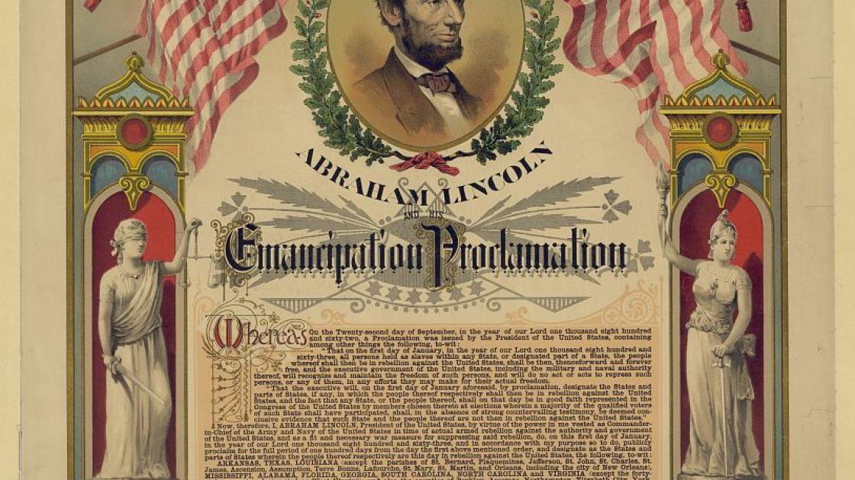

Reconstruction
- Presidential Reconstruction
- Wade-Davis Bill (1864)
- “Ten-Percent Plan”
- Andrew Johnson
- Freedmen’s Bureau
- John Wilkes Booth
- Lincoln’s assassination
- Black Codes
- Congressional Reconstruction
- “Radical Republicans”
- Charles Sumner
- Thaddeus Stephens
- Benjamin Wade
- Reconstruction Acts, 1867
- Tenure of Office Act, 1867
- Edwin Stanton
- impeachment
- “Scalawags”
- “Carpetbaggers”
- Blanche K. Bruce
- Hiram Revels
- Sharecropping
- tenant farming
- Ku Klux Klan
- Force Acts, 1870, 1871
- Amnesty Act, 1872
- Andrew Johnson [President, 1865—1869]
- Presidential Election of 1868
- Ulysses Grant [President,
1869-1877]
- patronage
- Thomas Nast
- Liberal Republicans
- Horace Greeley
- Panic of 1873
- “Redeemers”
- Rutherford B. Hayes
- Samuel J. Tilden
- Compromise of 1877

