Name ___________________________________________ DUE: Thursday, March 7th
Instructions:
- As a group, complete your assigned practice SAQ question using a GoogleDoc format.
- Use the computers/I-pads to conduct your research in sub-groups of 2-3 team members and complete one part of the question.
- Include three pieces of information for each part of the question for a total of nine responses.
- This is a timed assignment, so research, discuss, and answer each question with accurate and relevant information.
- Be prepared to present your group’s work to the class.
Question 1 is based on the following excerpts. GROUP 1
“[In the Civil War,] great issues were at stake, issues about which Americans were willing to fight and die, issues whose resolution profoundly transformed and redefined the United States. The Civil War was a total war in three senses: It mobilized the total human and material resources of both sides; it ended not in a negotiated peace but in total victory by one side and unconditional surrender by the other; it destroyed the economy and social system of the loser and established those of the winner as the norm for the future . . . The North went to war to preserve the Union; it ended by creating a nation.”
-James M. McPherson, historian, "A War That Never Goes Away," American Heritage, March 1990

“Should we consecrate a war that killed and maimed over a million Americans? Or should we question . . . whether this was really a war of necessity that justified its appalling costs? . . . ‘Very few Northerners went to war seeking or anticipating the destruction of slavery. They fought for Union, and the Emancipation Proclamation was a means to that end: a desperate measure to undermine the South and save a democratic nation that Lincoln called 'the last best, hope of earth.’ . . . "From the distance of 150 years, Lincoln's transcendent vision at Gettysburg of a ‘new birth of freedom' seems premature . . . . Rather than simply consecrate the dead with words, he said, it is for 'us the living' to rededicate ourselves to the unfinished work of the Civil War?”
-Tony Horwitz, journalist and writer, "150 Years of Misunderstanding the Civil War," The Atlantic, June 2013

Using the excerpts, answer a, b, and c.
a) Briefly explain ONE major difference between McPherson's and Horwitz's historical interpretation of the Civil War.

b) Briefly explain how ONE development from the period 1861 to 1865 not directly mentioned in the excerpts supports McPherson's argument.

c) Briefly explain how ONE development from the period 1861 to 1865 not directly mentioned in the excerpts supports Horwitz's argument.
Question 2. GROUP 2
Answer a, b, and c.
- Briefly explain why ONE of the following best supports the view that slavery largely ended during the Civil War before the passage of the 13th Amendment.
• President Abraham Lincoln
• United States Congress
• enslaved African Americans

- Contrast your choice against ONE of the other options, demonstrating why that option is not as good as your choice.

- Briefly describe what role, if any, slaves played in the war.

Question 3 is based on the following cartoon. GROUP 3
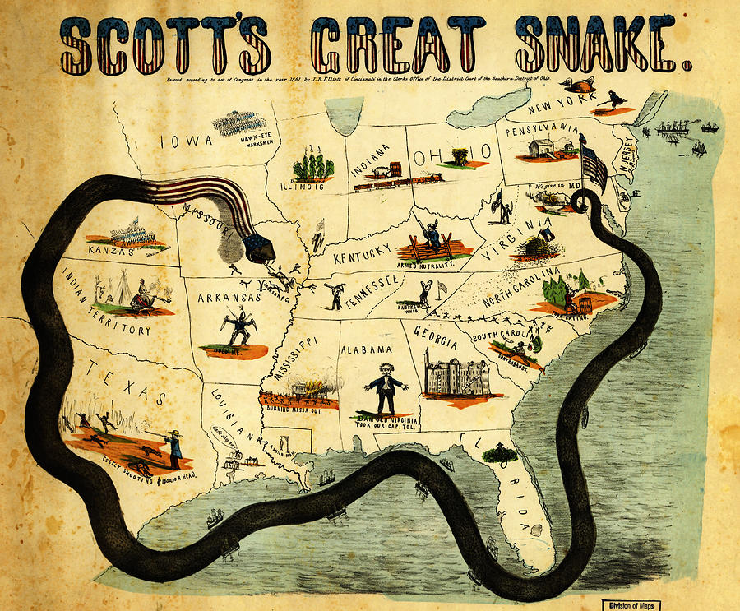
Answer a, b, and c.
- Explain the point of view reflected in the cartoon above regarding ONE of the following.
• blockade
• Mississippi River
• General Ulysses S. Grant

- Explain how ONE element of the cartoon expresses the point of view you identified in Part A.

- Explain how the point of view you identified in Part A helped to shape ONE specific action between 1861 and 1865.

Question 4. GROUP 4
Answer a, b, and c.
- Briefly explain why ONE of the following best supports the view that Lincoln was one of the most democratic and also one of the most autocratic of presidents.
• Emancipation Proclamation
• Gettysburg Address
• habeas corpus

- Contrast your choice against ONE of the other options, demonstrating why that option is not as good as your choice.

- Briefly identify ONE other president you believe combined the two qualities mentioned in the statement above.

